MICROSCOPE Name: _________________________
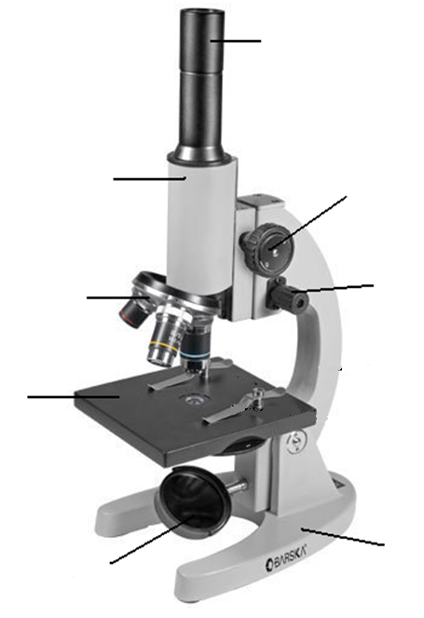

Magnification
The ocular lens has a magnification of ________________
There are three objective lenses. The three magnifications are _________, __________ and _________.
The total magnification is the ocular magnification ______________ the objective magnification.
For example, if the ocular magnification is 10x and the objective magnification is 40x the total magnification would be ___________.
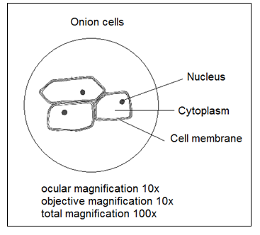
How to draw what you see under a microscope
Must use a sharp lead pencil (no colour!).
Draw in 2D not in 3D (flat drawing).
Only draw what you can see.
Do not shade in. Draw the main outlines and structures.
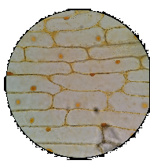
Include a title of what it is you are looking at.
Include the ocular magnification, objective magnification and total magnification.
Neatly label the main structures using a ruler to draw a line to the structures. What is seen under the microscope. How to safely use a microscope
_____________________________________________________________________________________
_____________________________________________________________________________________
_____________________________________________________________________________________
_____________________________________________________________________________________
_____________________________________________________________________________________
_____________________________________________________________________________________
_____________________________________________________________________________________
_____________________________________________________________________________________
_____________________________________________________________________________________
_____________________________________________________________________________________
_____________________________________________________________________________________
_____________________________________________________________________________________
_____________________________________________________________________________________
_____________________________________________________________________________________
_____________________________________________________________________________________
_____________________________________________________________________________________
_____________________________________________________________________________________
_____________________________________________________________________________________
_____________________________________________________________________________________
_____________________________________________________________________________________
_____________________________________________________________________________________
_____________________________________________________________________________________
_____________________________________________________________________________________
_____________________________________________________________________________________
_____________________________________________________________________________________
_____________________________________________________________________________________
_____________________________________________________________________________________
_____________________________________________________________________________________
_____________________________________________________________________________________
_____________________________________________________________________________________

